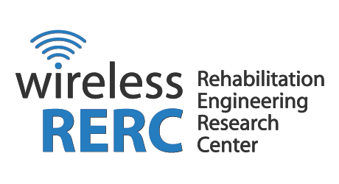

Comments of the Wireless RERC Concerning the NWS Experimental Winter Hazards Simplification Demonstration, March 22, 2013
The Rehabilitation Engineering Research Center for Wireless Technologies (Wireless RERC) mission is to research, evaluate and develop innovative wireless technologies and products that meet the needs, enhance independence and improve the quality of life and community participation of people with disabilities. Our consumer research team conducts surveys, focus groups and product evaluations to collect qualitative and quantitative data on a variety of use and usability content areas including, mobile user interfaces, emergency alerting and access to 911.

The Wireless RERC commends the NWS in its efforts to simplify and clarify the language used to convey emergency weather information. The content of emergency messaging is critical to prompting citizens to take immediate and appropriate protective actions. Through our research with people experiencing hearing loss whose primary language is American Sign Language (ASL), we have learned that the wording commonly used in emergency weather messages can be confusing when translated into ASL. Participants in focus groups that explored the utility of Wireless Emergency Alerts in ASL video formats emphasized that some phrases and expressions do not translate well into Deaf English or are otherwise not easily understood by people who are deaf. Specifically, idiomatic expressions that have entered mainstream English, such as “low lying areas” and “take cover”, could result in delayed reactions or no actions taken at all.

ASL is the fourth most common language used in America. It has all the essential features a language requires for functionality: rules for grammar, punctuation and syntax. According to participants in field trials conducted by the Wireless RERC, it is preferable to accommodate deaf individuals who utilize ASL as their primary language with ASL interpretation of written or spoken English. Since national, state and local alerting systems rely on the NWS for weather related emergency information and pass through identical verbiage which may be translated by sign language interpreters, it is critical that the NWS language be clear and remove any jargon, truncated text or idiomatic expressions. To that end, we recommend that the NWS contact organizations representing the interests of people who are Deaf and request that the proposed language be vetted amongst people whose primary language is ASL. We are in the process of developing an ASL Video Clip library of emergency terms that have been vetted by the ASL community. We will share it with NWS as it is developed and we encourage the NWS to submit nomenclature to be included in our ASL Video Clip Library.

Should you have any questions concerning our recommendation, please do not hesitate to contact Wireless RERC Principal Investigator, Helena Mitchell, via email at helena.mitchell@cacp.gatech.edu.

The Rehabilitation Engineering Research Center for Wireless Technologies (Wireless RERC) is sponsored by the National Institute on Disability and Rehabilitation Research (NIDRR) of the U.S. Department of Education under grant number H133E110002. The opinions contained herein are those of the authors and do not necessarily reflect those of the U.S. Department of Education or NIDRR.

