APRIL 14, 2016  EMERGENCY LIFELINES  WORKSHOP & TABLETOP  SUMMARY REPORT |  | Update on Federal, State, and Local Emergency Communications  State and Local Initiatives  Emergency Communications: Themes and Challenges  Research and Development  Posters and Demos  Winter Storm Tabletop Exercise  www.wirelessrerc.org  www.cacp.gatech.edu

ACKNOWLEDGEMENTS

National Institute on Disability, Independent Living, and Rehabilitation Research (NIDILRR)
This event was conducted under a grant from the National Institute on Disability, Independent Living, and Rehabilitation Research (NIDILRR grant number 90RE5007-01-00), is an agency within the Administration for Community Living (ACL), Department of Health and Human Services (HHS). The opinions contained in this report are those of the Wireless RERC, and do not necessarily reflect those of the U.S. Department of Health and Human Services or NIDILRR.

Center for Advanced Communications Policy, Georgia Institute of Technology
This event was supported, in part, by Georgia Institute of Technology’s Center for Advanced Communications Policy (CACP). CACP focuses on key issues that influence the development, implementation, and adoption of cutting-edge, advanced communications technologies. CACP, in its role as an objective and neutral source, collaborates with government, industry and academia at the national, local, state, and international levels. CACP is the home of The Rehabilitation Engineering Research Center for Wireless Technologies (Wireless RERC).
Special thanks to: Christina Touzet (CACP), Workshop and Tabletop Coordinator; Tom Kempton (CACP Consultant), Tabletop Facilitator; and Salimah LaForce (CACP), Themes and Challenges Moderator.

Purpose
The Rehabilitation Engineering Research Center for Wireless Technologies (Wireless RERC) hosted the Emergency Lifelines Workshop & Tabletop on April 14, 2016, at Georgia Institute of Technology. Forty-four (44) individuals with active leadership roles in emergency communications attended the invitation-only event. The event engaged representatives from academic, local, state, and Federal agencies to better understand the needs of individuals with disabilities during emergency situations, whether natural or manmade. The main purpose of this one-day event was to heighten awareness of strategies for communicating timely, accessible, lifesaving information over multiple wireless platforms. The intended objective of the event was to increase emergency communications between public safety officials and vulnerable populations, particularly people with disabilities.

Overview of Workshop
The Emergency Lifelines Workshop consisted of two panels. The panelists discussed the efforts they have used during emergencies to reach individuals with disabilities (see workshop program attachment).

Update on Federal, State, and Local Emergency Communications
The first panel, Update on Federal, State, and Local Emergency Communications, was moderated by Helena Mitchell, Ph.D. The panelists included Charles McCobb, Mary Hudak, and Susan Loeffler. Charles McCobb, Program Manager of the IPAWS Division - FEMA/DHS, gave an overview of the Integrated Public Alert and Warning System (IPAWS). He touched on the future of emergency notification systems and the importance of leveraging communications pathways via both connected and unconnected devices. Additionally, he discussed Executive Order 13407 which mandates IPAWS to “include in the public alert and warning system the capacity to alert and warn all Americans, including those with disabilities and those without an understanding of the English language.” Charles noted that the National Continuity Programs Office (home of IPAWS) worked with universities, such as Georgia Institute of Technology, and with disability advocates such as Deaf Link, Inc., to implement the Executive Order. He closed with a discussion on efforts of IPAWS to improve message comprehension by non-English speakers and for those for whom English is a second language using a set of national symbols created for use with emergency messages.
Mary Hudak, the External Affairs Director of FEMA Region IV, explained regional level emergency communications operations strategies; specifically, how critical it is to engage the Whole Community. She noted the importance of working with independent living centers in each state and the importance for each joint field operation facility to offer assistive technology kits at their disaster recovery centers. She explained the FEMA app and encouraged attendees also to review the ready.gov website (https://www.ready.gov/) and prepare a “Go Kit” in the case of an emergency. The Federal Emergency Management Agency (FEMA) coordinates recovery efforts with nonprofit organizations that work with, and for, people with disabilities, state coalition partners, and social and support clubs for people with hearing disabilities, to reach the whole community. “We aim to give the right information at the right time so people can make the right decisions,” said Mary Hudak.
Susan Loeffler, Director of the DeKalb Emergency Management Agency, provided insight on how her agency utilizes CodeRED, a safety app that delivers real-time emergency, community and missing person alerts from public safety officials, social media, and coordinates with local organizations to successfully reach their population of people with disabilities. Currently, DeKalb County issues Code Red alerts, however, only 5% of the population have currently opted into the CodeRED alert system. As a result, since IPAWS is an opt-out system, DeKalb Emergency Management Agency is in the process of becoming an IPAWS alerting authority to reach a larger percentage of the population. It is critical to create an initiative, similar to the fire drill initiatives, to get emergency preparedness information into the school systems; when you reach the kids, they will share the information with their parents. Additionally, she discussed the creation of emergency preparedness guidelines (EPGs) for the Deaf community and the use of neighborhood websites to reach the whole community and offer resources during emergency situations. DeKalb County also uses Instagram, Facebook, and Twitter to monitor social media, provide pictures of emergency scenes, and post information for their followers.
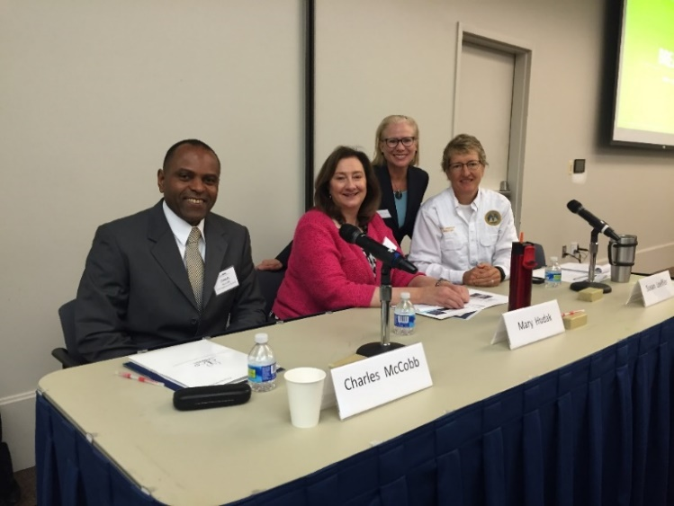
  - Panel #1: Charles McCobb, Mary Hudak, Helena Mitchell (moderator), and Sue Loeffler.

State and Local Initiative Panel
The second panel, State and Local Initiatives, was moderated by Rick Wimberly, Galain Solutions. The panelists included Wayne Smith, Betsy Kagey, Ph.D., Jennifer Hogan, and Kay Chiodo. Wayne Smith, Director, Operations Division, Georgia Emergency Management and Homeland Security Agency (GEMA), provided insight on how GEMA and other organizations at the state level coordinate with all 159 counties in Georgia. He noted that it is necessary to connect and communicate with the local governments to reach the many different populations throughout the state. State level authorities rely on the local level governments to reach local populations unless state level assistance is necessary, and requested. Wayne touched on the fact that there are six different National Weather Service (NWS) offices that monitor the state of Georgia. He discussed the role the NWS plays in providing information for emergency communications throughout the state during a weather event.
Dr. Betsy Kagey, Academic and Special Projects Liaison at the Georgia Department of Public Health (GDPH), provided an overview of public health in Georgia and examples of the various ongoing programs which provide services to the public on a daily basis. She provided information on the roles and responsibilities of the Georgia Department of Public Health Office (GDPH) of Emergency Preparedness and Response. Specifically, on the types of emergencies they prepare for including response to novel viruses such as H1N1 (Swine Flu) and Ebola; hazardous weather events such as flooding, ice storms and hurricanes; and man-made events such as chemical spills and terrorism. As a member of the Georgia Emergency Preparedness Coalition for Individuals with Disabilities and Older Adults, GDPH identifies and engages in planning with at-risk individuals, local agencies, community-based organizations, and community healthcare providers. Understanding that all response is local, Dr. Kagey’s department initially works within the community to stress personal preparedness for individuals and families, as well as continuity of operation plans (COOP) for agencies, organizations and healthcare providers.
Jennifer Hogan, Disaster Preparedness Coordinator at the Division of Aging Services, Georgia Department of Human Services, spoke about the Georgia Emergency Preparedness Coalition for Individuals with Disabilities and Older Adults. Ms. Hogan provided attendees with pocket reference guides that provide information and stress awareness on how to identify and respond to the unique needs of people with disabilities in an emergency. Kay Chiodo, CEO of Deaf Link Inc., talked about accessible emergency communications and how important it is to incorporate ASL video features into emergency alerts. She highlighted the need to involve the Deaf population in testing while developing wireless devices that alert populations with disabilities. Every Deaf individual is unique, and it is important not put them in one silo and say the problem is solved, especially at disaster recovery centers (DRCs).
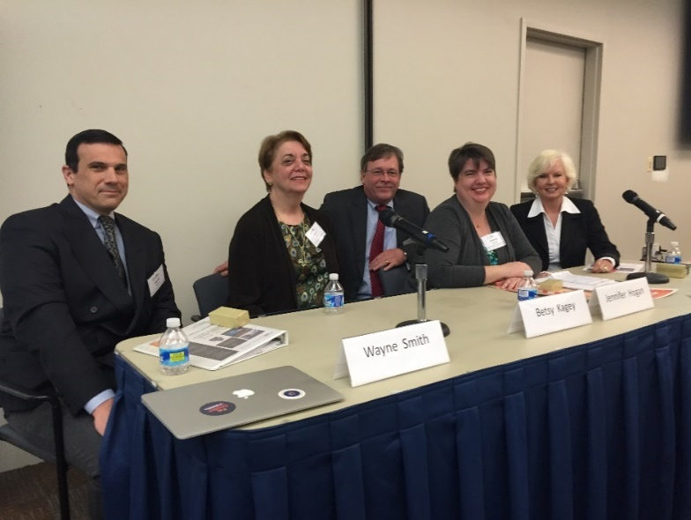
  - Panel #2: Wayne Smith, Betsy Kagey, Rick Wimberly (moderator), Jennifer Hogan, Kay Chiodo.

Posters and Demonstrations
Following the two panel discussions, there was a poster and demonstration session focused on emergency communications research, interactive accessible wireless technology, and available resources from Federal agencies and organizations including Hamilton/Georgia Relay, FEMA IPAWS, FEMA Region IV, Georgia Emergency Preparedness Coalition for Individuals with Disabilities and Older Adults, and the American Red Cross. Demonstrations of accessible wireless technology included the Accessible Weather App, the Wireless RERC’s prototypes, Accessible Wireless Emergency Alerts with ASL video, and the Emergency Alert Device and WEA messaging system; and Deaf Link Inc.’s advancements to assist the Deaf community during emergency conditions.

Overview of Tabletop Exercise
The afternoon was dedicated to a Winter Storm Tabletop Exercise – a Discovery & Exploration, featured National Weather Service (NWS) generated weather watches and weather warnings for a winter storm in the Atlanta metro area. The tabletop exercise consisted of modules that reviewed different types of winter weather alerts, warnings and watches (see tabletop program attachment). Each table was preassigned to reflect real time agency diversity and collaboration during an actual incident. Participants discussed each of the modules as a table and troubleshot different emergency communications efforts, including transmitting to wireless devices. Each table was asked to be mindful of how they would provide information to people with disabilities, and to share successful strategies. The aim was to discuss issues that could arise throughout the alert and warning stages and how to communicate those issues in an accessible manner. Each table facilitator encouraged their group to (1) examine some of the potential impacts to people with disabilities, (2) draw up a plan that included people with disabilities in the planning stages, (3) develop accessible press releases, and (4) disseminate via posts on websites, apps, social media, and mobile alerting platforms, and in short, to saturate media outlets.

As each table reported their findings, several issues emerged:
- Not all state and local agencies have separate and distinct warning channels for the wide range of publics they serve.
- Many people with disabilities are more connected to portable electronic devices than most agencies are aware of.
- While government agencies use a variety of online, social media resources to connect with people with disabilities, these channels are not dedicated to warnings or provision of information regarding disasters or other emergencies.
- Not all broadcast TV and radio stations make use of the resources for warnings in non-English languages.
- The written crawl or written word warning on screen is not always at the best resolution for people with low vision.
- There is substantial opportunity for state and local officials to work with people with disabilities to establish regular communications in a variety of formats to achieve accessibility and Whole Community understanding. It is not a one-way interaction. With consistent and regular use, these types of communications are already operational when they are needed to inform or direct the public in an emergency.
- While emergency alerting via FEMA IPAWS is beginning to be deployed to many local agencies, there is also an ongoing discussion on frequency and types of message dissemination.
- Individuals with functional health needs should be included in planning, especially those living in nursing homes.
- Utility, service and retail entities such as Georgia Power, UPS, and large retailers like Walmart and Costco that are near facilities with older adults and/or housing for people with disabilities, need to be included in emergency planning.
Unlike most table-top exercises, this discussion was not designed to solve the scenario but rather stimulate exploration on how to foster the most inclusive messaging possible, especially using wireless device platforms.

Themes & Challenges Survey
Attendees had the chance to participate in a survey to identify themes and challenges within four different stages of emergency communications. The survey results below, discussed during the concluding session of the workshop and tabletop event, identified the top challenges for the four themes in emergency communications.
- Awareness & Outreach: 67% of respondents identified that creating an accessible awareness campaign on available emergency information sources such as WEA, Ready GA app, emergency management social media feeds, and subscription-based mobile alerting as the #1 challenge.
- Education & Training: 39% of respondents indicated that developing WEA training opportunities covering the accessibility needs of people with disabilities for emergency officials, media, and government personnel, was the #1 challenge.
- Inclusive Emergency Alerts: 41% of respondents suggested that awareness of the need for accessible formats (ASL, large print, captions, text-to-speech, alt-text, etc.) and experience in creating the same was the #1 challenge.
- Sheltering: 45% of respondents noted that ensuring multiple agencies coordination and provision of accessible information to the shelter population was the #1 challenge.
Survey respondents were asked to consider three challenges for the awareness and outreach theme and rank each challenge first, second, third in terms of importance. Sixty-seven percent (67%) of survey respondents ranked creating an accessible awareness campaign about emergency information sources as the most important and first awareness and outreach challenge. Forty-one percent (41%) of respondents ranked educating the public on the distinction between “warning”, “watch” and “advisory” emergency messages as the second most important challenge. Educating the public about the distinction between a WEA message and subscription-based alerts was ranked by 61% of respondents as the third challenge.

Survey respondents were asked to review four challenges to inclusive emergency alerting and rank each challenge in order of importance. Forty-one percent (41%) of survey respondents ranked knowledge and need for accessible formats as the primary challenge within the theme of inclusive emergency alerting followed closely by the need for emergency managers to utilize various available communications systems to disseminate emergency information. The third most important challenge, (41% of respondents) was that emergency alerts are text-centric; the limited use of images and video by alerting systems is a barrier to comprehension of the message. The final challenge was the need for better delivery of verbal descriptions of on-screen informational graphics by media.

Survey respondents were asked to review the three challenges for the education and training theme and rank each challenge. Thirty-nine percent (39%) of survey respondents ranked developing WEA training opportunities as the primary challenge within education & training. The second most important challenge, at 38%, was educating local officials on partnering with the media. The third challenge, at 36%, was that there are not enough options available for language translation and accessible formatting for emergency management agencies. Fifty percent (50%) of respondents ranked fourth, the challenge statement “use of IPAWS training modules to increase alert and message creation among the emergency community of responders.”

Survey respondents were asked to review the three challenges for the sheltering theme and rank each challenge. Forty-five percent (45%) of respondents ranked ensuring multiple agencies coordinate and provide accessible information to the shelter population as the 1st challenge. For the 2nd challenge, all options were ranked equally by respondents, making it statistically difficult to distinguish except in relationship with the other ranked challenges, the second challenge by default is “make audio announcements, signage, and handouts accessible.” The third most important challenge, ranked by 46% of respondents, was to create daily spontaneous communication accessible to shelter staff and the shelter population. Going forward, the data indicates that it is necessary to bring together agencies before the incident to ensure accessible communications for the Whole Community, also reflected in the panel remarks.

Event Evaluation
At the conclusion of the event, the attendees were asked to complete an evaluation form. On a scale of 1-5, attendees ranked both the quality and value of the event. The aggregated rankings for quality and value were 4.67 and 4.71, respectively. Attendees reported the following benefits from the day: greater awareness of communicating effectively with individuals with disabilities during emergencies; networking; expanding horizons; gained knowledge in new areas; learned how to communicate with different agencies; excellent opportunity to learn from other experts and share mutual experiences and lessons learned; learned various challenges related to inclusion of people with disabilities or those with access and functional needs. Several respondents suggested that the survey should be offered before the event via email or upon arrival (which it was) at the event rather than during the lunch hour. Attendees stated they would prefer to take the survey at a different time and use the lunch hour for networking. This will be taken into account in future leadership workshops.
Respondents felt that the program was thought provoking and enhanced attendee’s knowledge concerning vulnerable populations in relation to preparedness, communication, and safety during emergency situations. Emergency communications and alerting dissemination organizations participated in the interactive event. Attendees reported that the event was informative and inclusive of the appropriate agencies.

Conclusions
The following are “takeaways” useful in developing a future emergency alerting leadership workshop:
- Develop a list of recommended action items to be addressed after the event.
- Work on addressing the top identified challenges through working groups such as the Georgia Emergency Preparedness Coalition for Individuals with Disabilities and Older Adults.
- Additional lessons learned in regards to emergency communications and people with disabilities should be presented to create real world situations for attendees.
- Workshops should be hosted annually.
- Additional stakeholders could include the National Weather Service, leadership of the Atlanta Hartsfield-Jackson International Airport, and public broadcasting station representatives to represent a broader set of key stakeholders.

