Learning from Older Adults

During Fall semester 2012, students at the School of Industrial Design at Georgia Tech spent 15 weeks at the Wesley Woods retirement community learning from older adults. The “studio” class, headed by Assistant Professor Dr. Claudia B. Rebola, focused on the full cycle of designing products from problem definition to design iteration and prototype deliverables. This advanced design course is one of the offerings under Building Research Capacity training project of the Wireless RERC, where students are provided an in-depth understanding how to design products considering universal design principles. As such, central to the class was the task of designing universal interactive products for older adults.

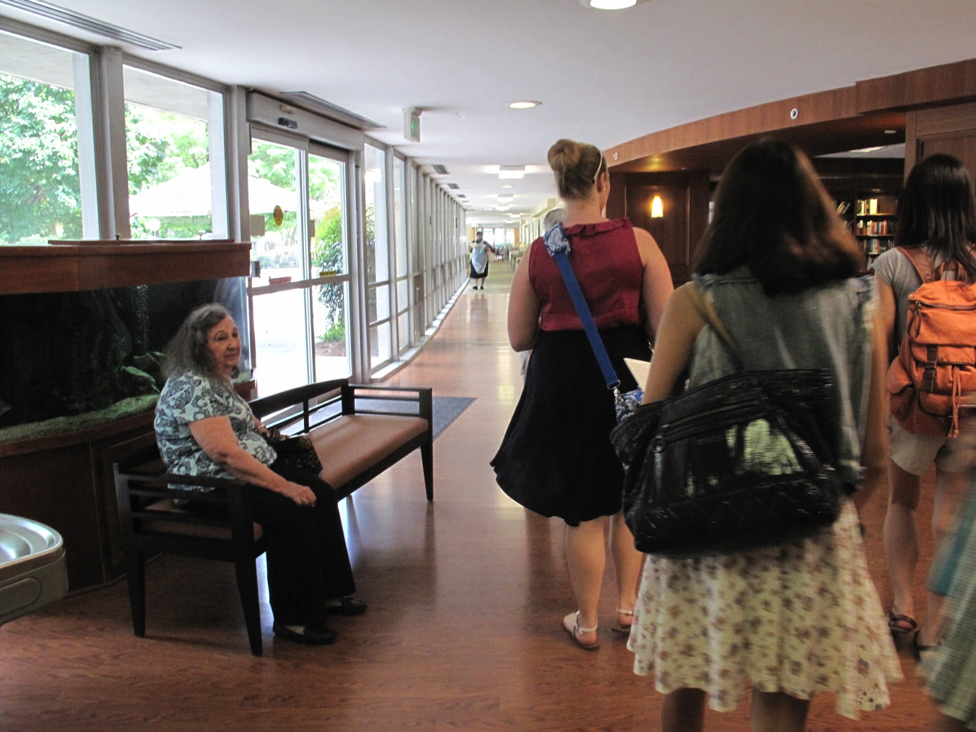
Students visiting Wesley Woods

The studio used varied instructional methods including presentations, lectures and in-class discussions, in-class feedback, readings, presentations and project reviews. But the success of the class was the ability for students to spend extended periods of time with their intended users. Students visited the Wesley Woods Towers retirement community once a week to spend time with the residents. Wesley Woods Towers, established in 1987 and component of Emory Healthcare, is a retirement home community in Atlanta specializing in providing the facilities and care needed to allow older adults to fully enjoy the benefits of senior living.

Students followed a contextual design process which includes observations of older adults dynamics at the community, personal interviews and conversations, and engaged in older adults activities such as playing cards, listening to music, to mention a few. Throughout the semester, students applied the knowledge from older adults into designing artifacts to support daily activities of residents. Students sketched ideas, analyzed research results through affinity diagrams, and developed mockups of concepts and prototypes.

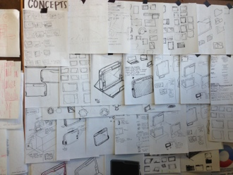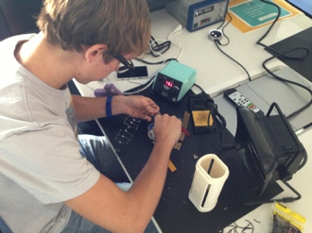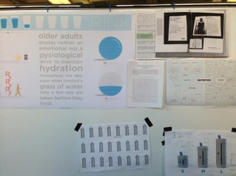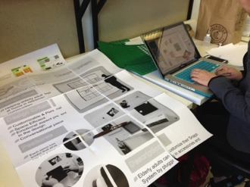
Students working on their projects

While designing interactive products, students applied the seven principles of Universal design and employed the assessment tool to evaluate their designs: equitable use, flexibility in use, simple and intuitive use, perceptible information, tolerance for error, low physical effort, and size and space for approach and use. In order to support the teaching, Jon Sanford showcased students’ examples of good and bad universally designed products. In addition, some of his students helped the studio class giving feedback to better design universal products. Students also got feedback on their design from Brian Jones, Project Director of the Wireless RERC Building Student Capacity project and Director of the Aware Home Research Initiative, and from experts on design for aging from the “Design and Technologies for Healthy Aging” (DATHA) Coalition Initiative, including Scott Morrison from BrightStar Care®.

At the end of the semester, students designed 7 universal design solutions that worked integrated as a system following a common brand identity. Students considered older adults’ basic needs (i.e. nutrition, wellness, socialization, security, cognition, to mention a few) and how these can inspire new design concepts. Solutions under the brand name “S*AGE: Simplifying Aging” included a new system to monitor water intake to encourage older adults to be hydrated; a community-based event planner system to encourage older adults to participate in social events; a home system to design resident spaces to make them feel at home; an ambient technology device to bring the sense of nature to the resident units; to mention a few. Solutions were showcased at the Wesley Woods Towers gaining awareness from residents and staff of the community. It was truly a successful experience as student learned to design products for the user, around the user and with the user. Solutions couldn’t have been better designed without the iterative testing and feedback from the residents in the community. Certainly, residents couldn’t have felt as happy by having young energetic students at their Wesley Woods retirement community home.

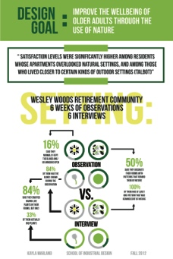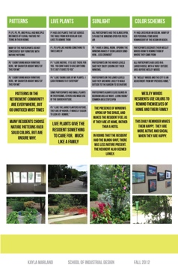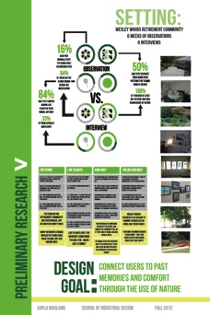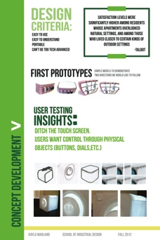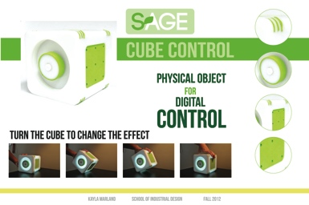
Students project

Acknowledgments:
We thank Wesley Woods retirement community personnel and resident for allowing access to their facilities. We also thank the Rehabilitation Engineering Research Center on Wireless Technologies for support of the class. This project was produced under the auspices of the Rehabilitation Engineering Research Center for Wireless Technologies (Wireless RERC), which is funded by the National Institute on Disability and Rehabilitation Research (NIDRR), United States Department of Education, under grant number H133E110002. The opinions contained in this paper are those of the authors and do not necessarily reflect those of the U.S. Department of Education or NIDRR.

